**Step-by-Step Solution for Azure Deployment**

**1. Set Up Azure Infrastructure**

**1.1. Create Resource Groups**

* Create two resource groups for the two regions:
  + **Central US**: ResourceGroupCentralUS
  + **West US**: ResourceGroupWestUS

# Using Azure CLI

**az group create --name ResourceGroupCentralUS --location centralus**

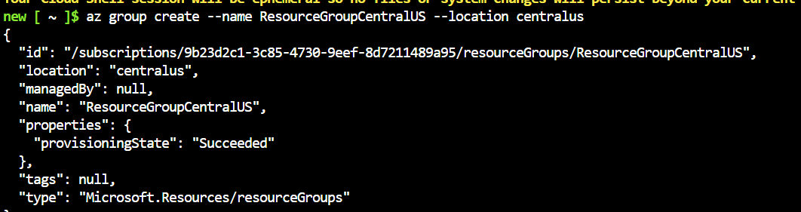

**az group create --name ResourceGroupWestUS --location westus**

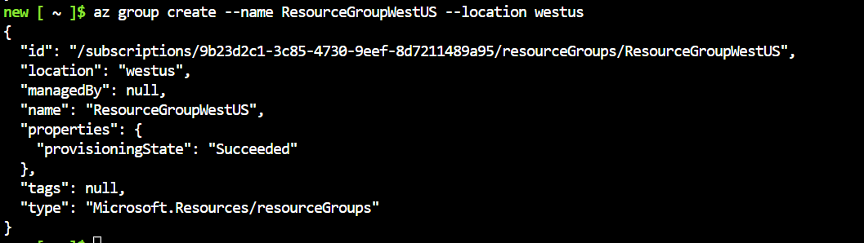

**1.2. Create Virtual Networks**

* Create two virtual networks, one for each region:

**az network vnet create --resource-group ResourceGroupCentralUS --name VNet1 --subnet-name Subnet1**

**az network vnet create --resource-group ResourceGroupWestUS --name VNet2 --subnet-name Subnet2**

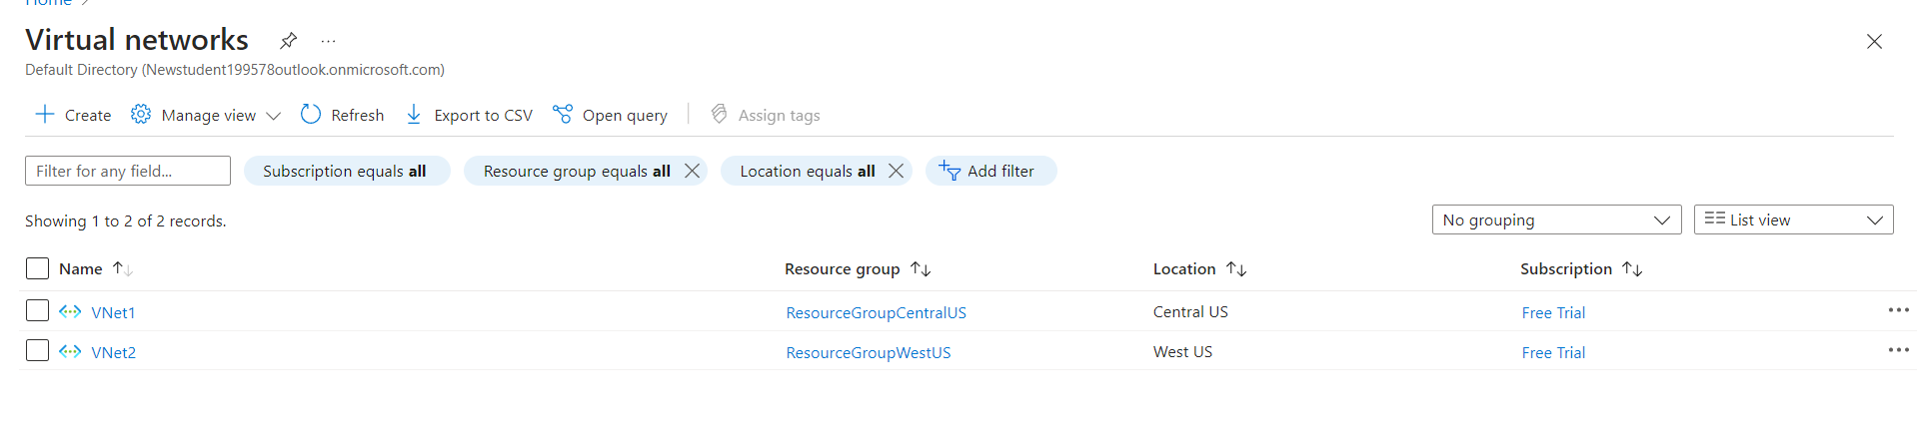

**1.3. Create Virtual Machines**

* Deploy VM1 in Central US and VM2 in West US.

**az vm create --resource-group ResourceGroupCentralUS --name VM1 --image Ubuntu2204 --vnet-name VNet1 --subnet Subnet1 --admin-username azureuser --generate-ssh-keys**

**az vm create --resource-group ResourceGroupWestUS --name VM2 --image Ubuntu2204 --vnet-name VNet2 --subnet Subnet2 --admin-username azureuser --generate-ssh-keys**

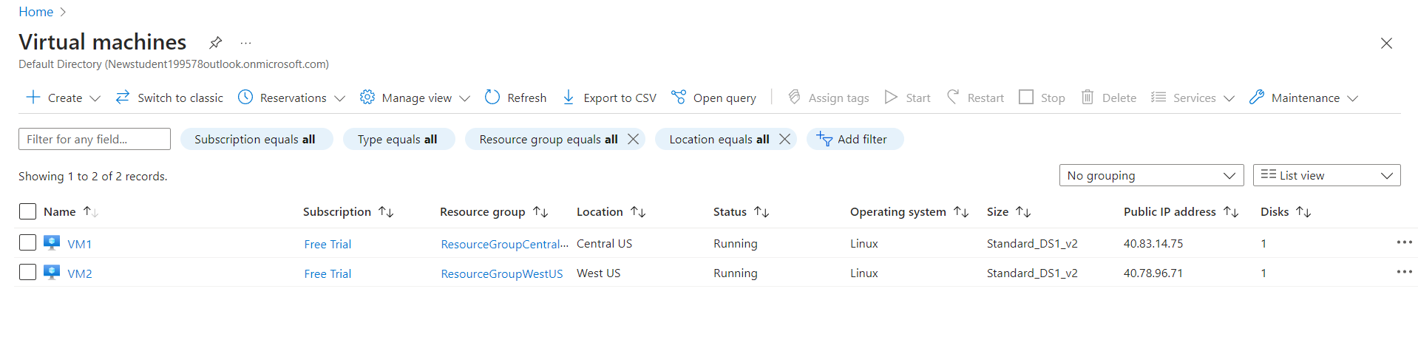

**1.4. Create V-net Peering**

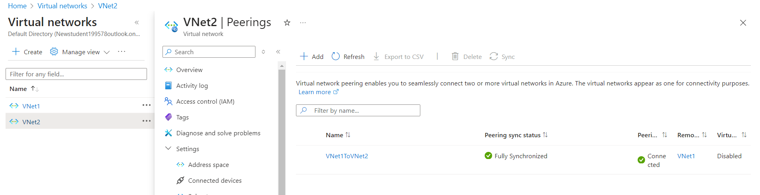

**2. Configure Storage Account**

**2.1. Create a Storage Account**

* Create a storage account in Central US for hosting the error.html file.

**az storage account create --name mystorageaccount199578 --resource-group ResourceGroupCentralUS --location centralus --sku Standard_LRS**

**2.2. Create a Blob Container**

* Create a container named upload.

**az storage container create --name upload --account-name mystorageaccount199578**

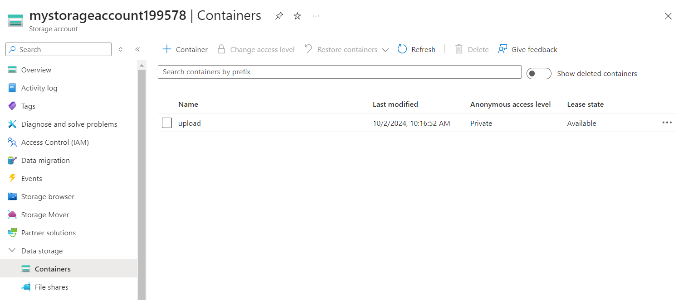

**2.3. Enable Static Website Hosting**

* Enable static website hosting and upload the error.html.

**az storage blob service-properties update --account-name mystorageaccount199578 --static-website true**

**az storage blob service-properties update --account-name mystorageaccount199578 --static-website --index-document index.html --404-document error.html**

**az storage blob upload --account-name mystorageaccount199578 --container-name \$web --name error.html --file /home/new/error.html**

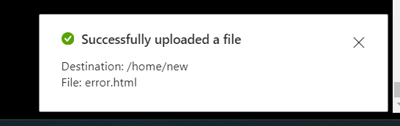

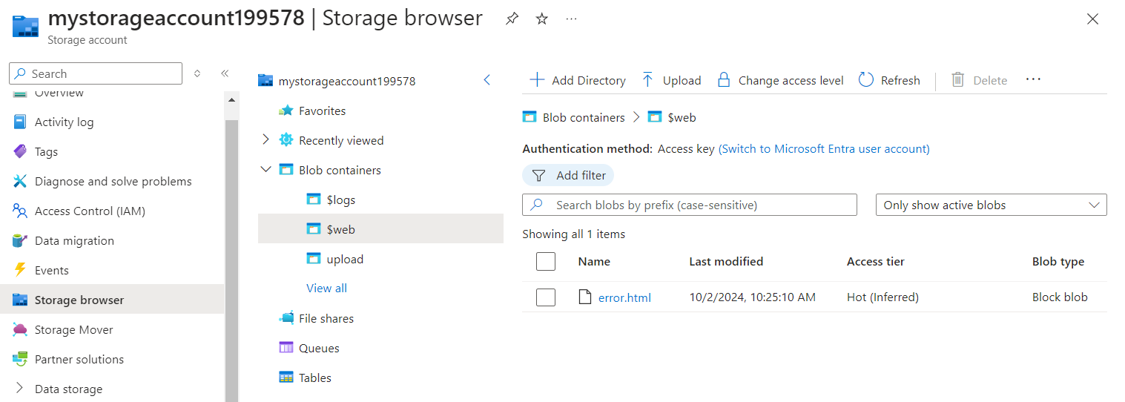

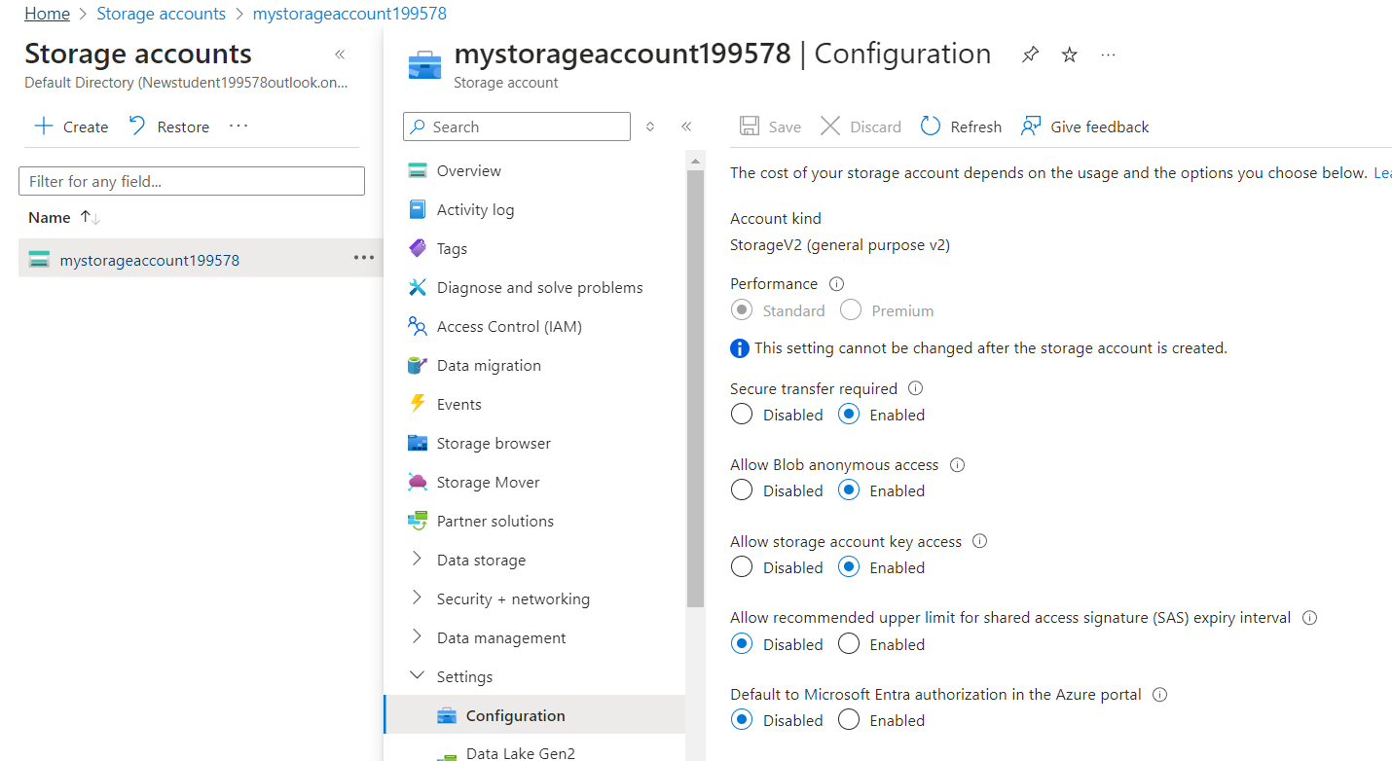

**3. SSH into Each VM, Clone the Repository** and **Run Deployment Scripts**

# On VM1

git clone https://github.com/azcloudberg/azproject.git

cd azproject

./vm1.sh

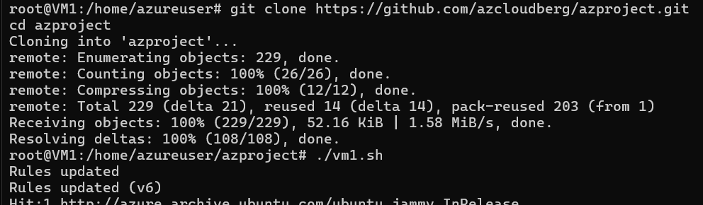

# On VM2

git clone https://github.com/azcloudberg/azproject.git

cd azproject

./vm2.sh

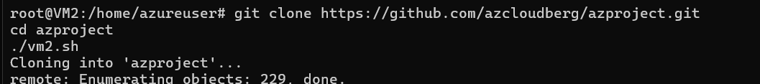

**5. Configure the Application**

**5.1. Edit Configuration Files**

* On VM1, open the config.py file and update the storage account details.

nano config.py

# Update the storage account information

**5.2. Run the Application**

# On VM1

sudo python3 app.py

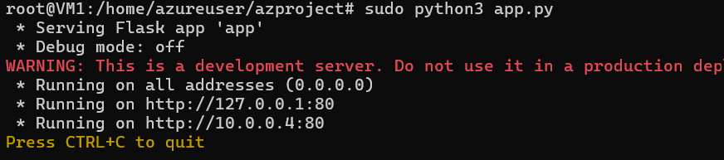

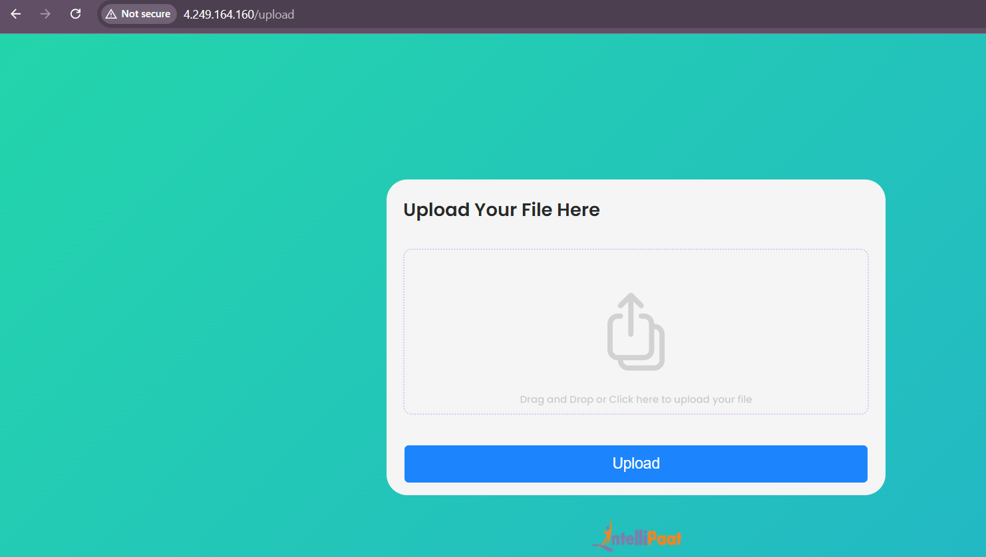

**6. Configure Application Gateway**

**6.1. Create Application Gateways**

* Create Application Gateways in both regions and set up the routing rules.

# Application Gateway for Central US

**az network application-gateway create --name myAppGateway2 --location westus --resource-group ResourceGroupWestUS --capacity 2 --sku Standard_v2 --public-ip-address MyAppGateway2PublicIp --vnet-name VNet1 --subnet default2 --servers "<private ip of vm>" --priority 100**

# Application Gateway for West US

**az network application-gateway create --name myAppGateway2 --location westus --resource-group ResourceGroupWestUS --capacity 2 --sku Standard_v2 --public-ip-address MyAppGateway2PublicIp --vnet-name VNet2 --subnet default --servers ""<private ip of vm>" --priority 100**

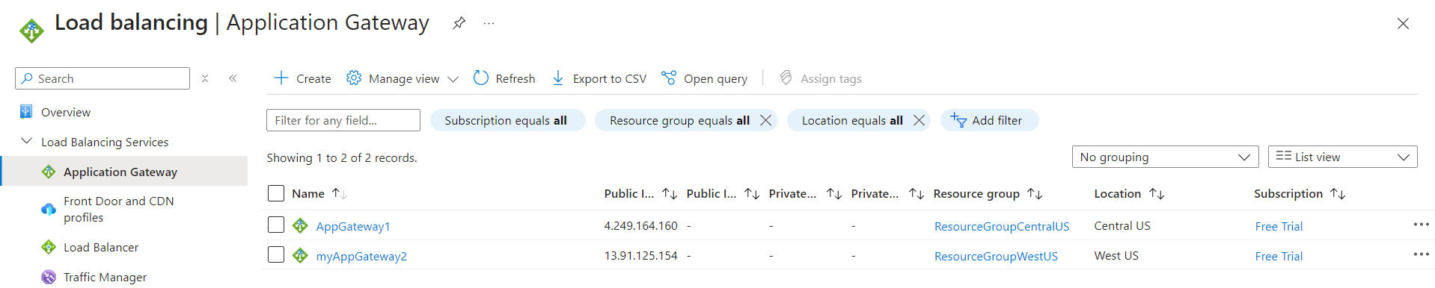

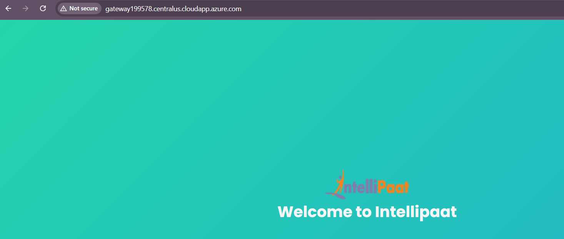

**6.2. Configure HTTP Settings and Routing Rules**

* + Under **Settings** in the left-hand menu, select **HTTP settings**.
  + Click on your existing HTTP setting or create a new one if required.
  + Scroll down to the **Custom error pages** section.
  + Set up the **Error page URLs** for 403 and 502 errors:
  + For **403 error**, use the URL of your error.html hosted in the Azure Storage Static Website (e.g., https://<storage-account-name>.z13.web.core.windows.net/error.html).
  + For **502 error**, use the same URL if desired.
  + After entering the custom error page URLs, click **Save**.

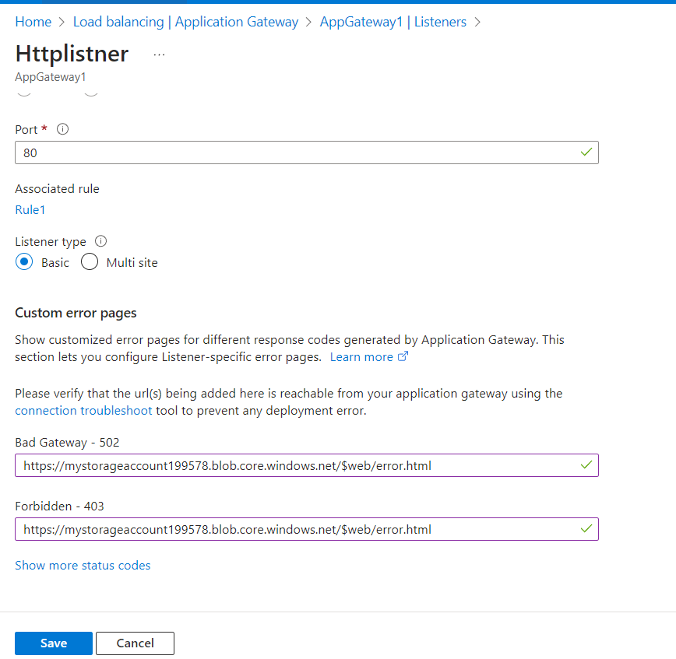

**7. Implement Traffic Manager**

1. **Create Traffic Manager Profile**:
   * Click on **Create a resource** and select **Networking** > **Traffic Manager profile**.
   * Fill in the details (name: MyTrafficManager199578, routing method: Performance).
   * Click **Create**.
2. **Add Endpoints**:
   * In the Traffic Manager profile, click on **Endpoints** and add both application gateways as endpoints.

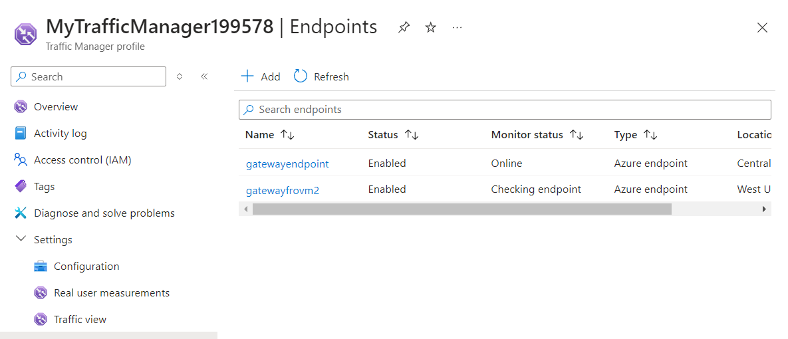

**9. Validate the Setup**

1. **Access the Application**:
   * Open a browser and go to http://mytrafficmanager199578.trafficmanager.net/ to test the application.

